Data set

Fact tables: returns and sales

🡪 we have to build dimensions

Procedure: -

Create a resource group:

* Tags are used to categorized

Storage account: -

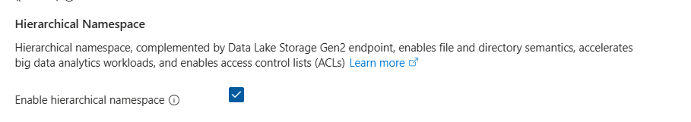

* This will create Data lake other wise BLOB storage account will be created
* In data lake we can create directories inside it but BLOB cannot provide

Azure Data Factory: -

-----> in the storage account create containers in the data source like as in medilion architecture. Bronze, silver and gold

* Launch studio in azure data factory
* Create pipeline
* A computer screen shot of a computer

  AI-generated content may be incorrect.
* Here sink is destination
* Link service is a connection, it needs to get data from github and push to data lake

* Create linked services

* Create for http and data lake, click on source create a httplinked and sink create a datalake one give bronze path

* Hectic process to create for each file, now we fetch data dynamically.

1. We have relative url file
2. Folder changes
3. File

* We will use for-each activity
* Create a json file
* A screenshot of a computer

  AI-generated content may be incorrect.
* Add all the relative urls
* Just create another container in data lake and add this json file in it
* Go to data factory add a lookup in dynamic pipeline and upload this file in it
* In the same pipeline we have a for each loop just drag the COPYGITDATA item.
* Go to activity of for each just add the parameters in source and sink tabs
* Boom! Just debug it mann!

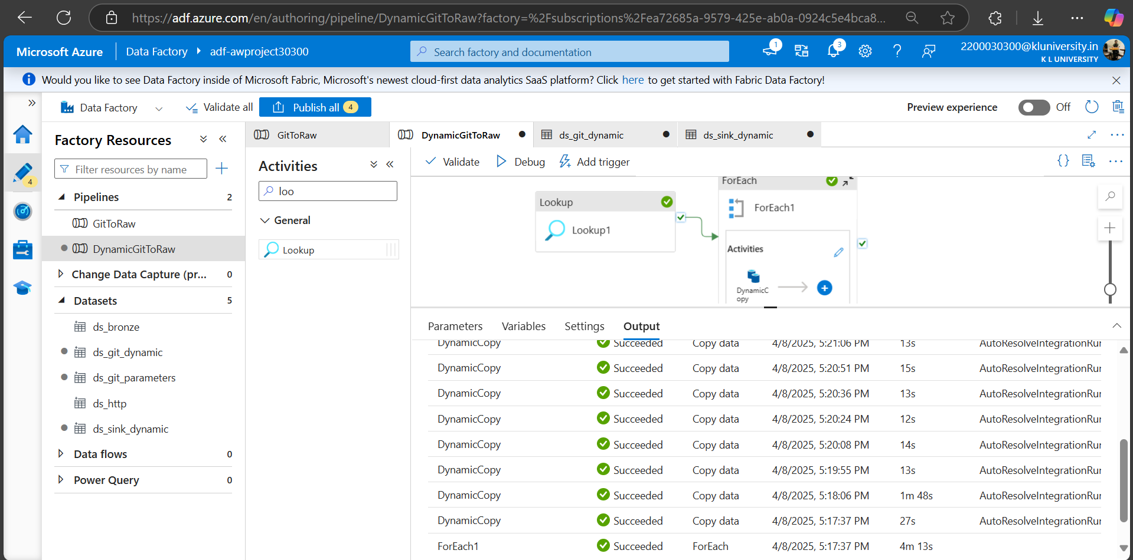

PHASE -2

🡺now we have to transform the data using databricks

🡪To deal with big data data bricks is used

🡪it is used for transformation layer

Create cluster

🡪it is auto managed we don’t need to manage

🡪 the data bricks needs key to access data lake, can be created using ENTRA ID

* Open entra id register an app and copy credential
* Open data lake then go to IAM just get secret key id
* Now open data bricks, start the compute engine (virtual machine)

PYSPARK

* In the workspace just add this below code and give the credentials which copied in previous steps  
  spark.conf.set("fs.azure.account.auth.type.<storage-account>.dfs.core.windows.net", "OAuth")  
  spark.conf.set("fs.azure.account.oauth.provider.type.<storage-account>.dfs.core.windows.net", "org.apache.hadoop.fs.azurebfs.oauth2.ClientCredsTokenProvider")  
  spark.conf.set("fs.azure.account.oauth2.client.id.<storage-account>.dfs.core.windows.net", "<application-id>")  
  spark.conf.set("fs.azure.account.oauth2.client.secret.<storage-account>.dfs.core.windows.net", service_credential)  
  spark.conf.set("fs.azure.account.oauth2.client.endpoint.<storage-account>.dfs.core.windows.net", "https://login.microsoftonline.com/<directory-id>/oauth2/token")
* df = spark.read.format("csv").option("header", "true").option("inferSchema",True).load('abfss://bronze-container@awstorage30300.dfs.core.windows.net/AdventureWorks_Calendar')
* inferschema: default the data in csv it takes as text data, we are telling spark to analyze the data on its own to decide it.
* Load:
  + abfss : azure blob storage

Adventure Calender

* df_cal = df_cal.withColumn('Month',month(col('Date')))\
* .withColumn('Year',year(col('Date')))
* df_cal.display()
* transformation to columnar data

modes:

* append: to apply union (merge data)
* overwrite: replace existing data
* error: write data that already existed
* ignore: if data is there in folder it does not thrown any error, it not write data

df_cal.write.format('parquet')\

    .mode('append')\

    .option("path","abfss://silver-container@awstorage30300.dfs.core.windows.net/AdventureWorks_Calendar")\

.save()

AdventureWorks – Customers

df_cus = df_cus.withColumn('fullName',concat_ws(' ',col('Prefix'),col('FirstName'),col('LastName')))

Products table:

Split: - to fetch desired index

Sales Table

df_sales = df_sales.withColumn('StockDate',to_timestamp('StockDate'))

df_sales = df_sales.withColumn('OrderNumber',regexp_replace(col('OrderNumber'),'S','T'))

df_sales = df_sales.withColumn('multiply',col('OrderLineItem')*col('OrderQuantity'))

BIG DATA ANALYTICS USING PY SPARK

df_sales.groupBy('OrderDate').agg(count('OrderNumber').alias('total_order')).display()

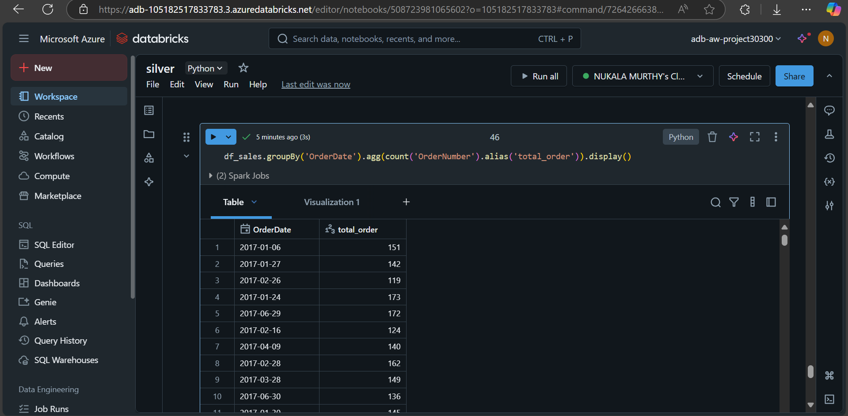

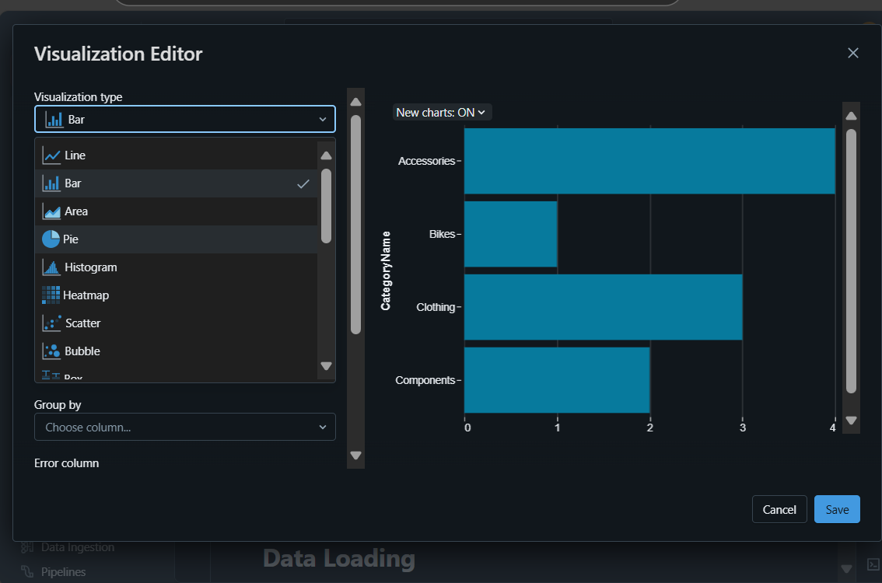

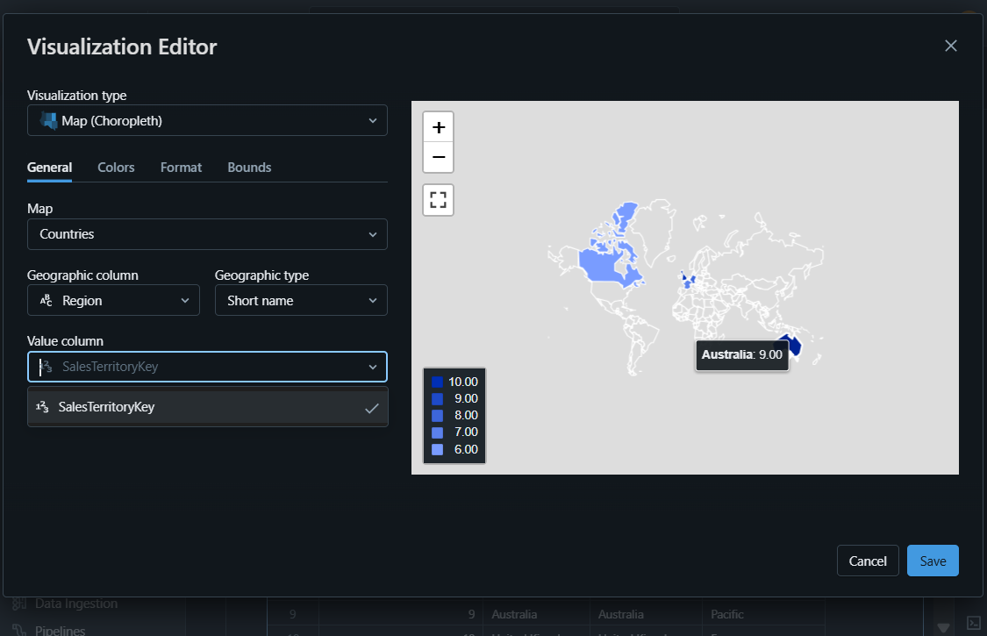

Done

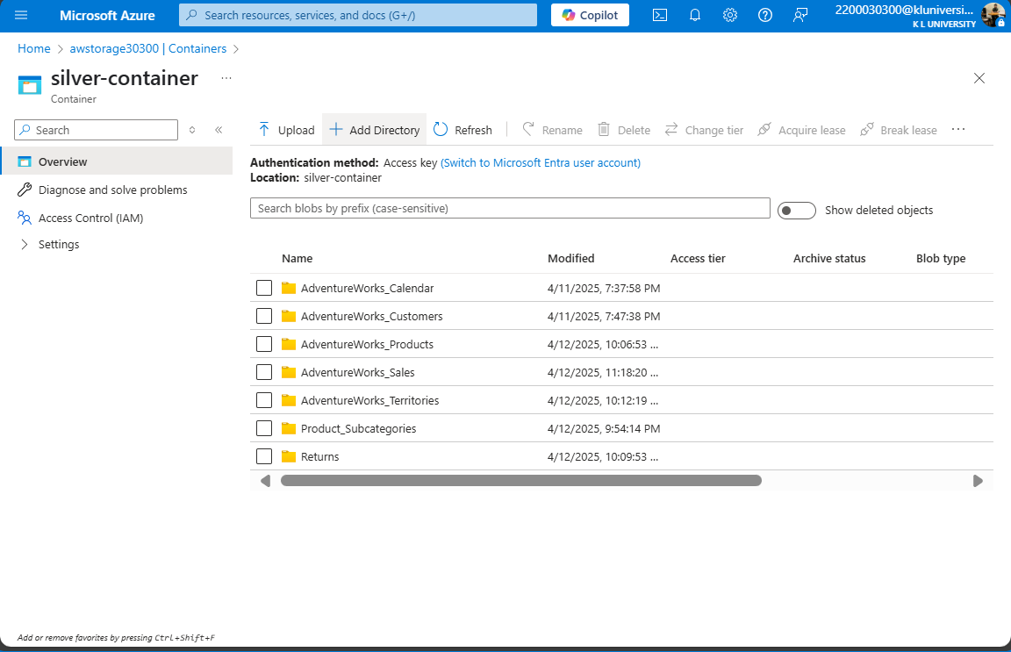

PHASE 3- GOLD LAYER

🡪synapse analytics is a unifed platform in which it combines

Azure data factory + Spark (Big Data Analytics) + Warehousing

🡪Synapse needs permission to access data Lake, MANAGED IDENTITY or SYSTEM MANAGED IDENTITY

Don’t use the same data lake that has used in previous layers.

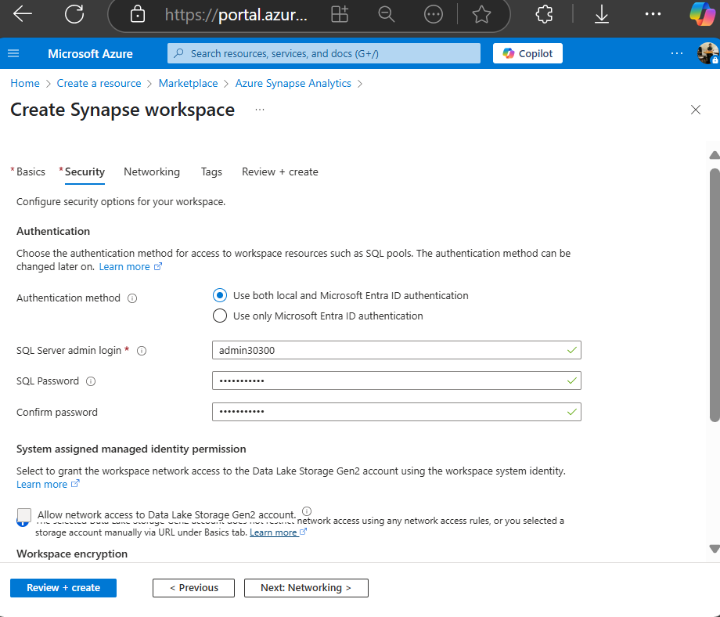

Note: - All regions are not working (US East, south india), Central US is working fine

🡪To give permission for synapse to access Data lake

* go to data lake then click on IAM add a role assignment of managed identity

pass: mypassword

-- come to synapse

Dedicated: it is a traditional way to store data, in which the data actually stored in mysql and postgresql

Serverless: no need to manage the server

Data resides in the data lake, in csv format

LAKE HOUSE, gives privilege to apply all database concepts to data lake

🡪 To Pull Data From the silver layer we can use openrowset()

Get the link from data lake ie, go to the file and copy link then change ‘blob’ to dfs

IAM access role assignment: Storage Blob Data Contributor

Allows for read, write and delete access to Azure Storage blob containers and dat

🡺 to create external tables in synapse, these steps are requires

Create credential

External data source

External file format